WS 2025/26

Lab course: Human Robot Interaction

Task 4: Teleoperation

Chair of Autonomous Systems and Mechatronics
Friedrich-Alexander-Universität Erlangen-Nürnberg

TEAM 1 :
Velayudhan Aravindakshan - ju08rufe
Akhilan David Karthikeyan - ug39owys
Wei Zhang - jo07wuwe

Exercise 1

The code was analysed with the understanding of basic C++ coding structure. The website of adafruit on FSR was also reviewed.Adafruit FSR1, Adafruit FSR use

Exercise 2
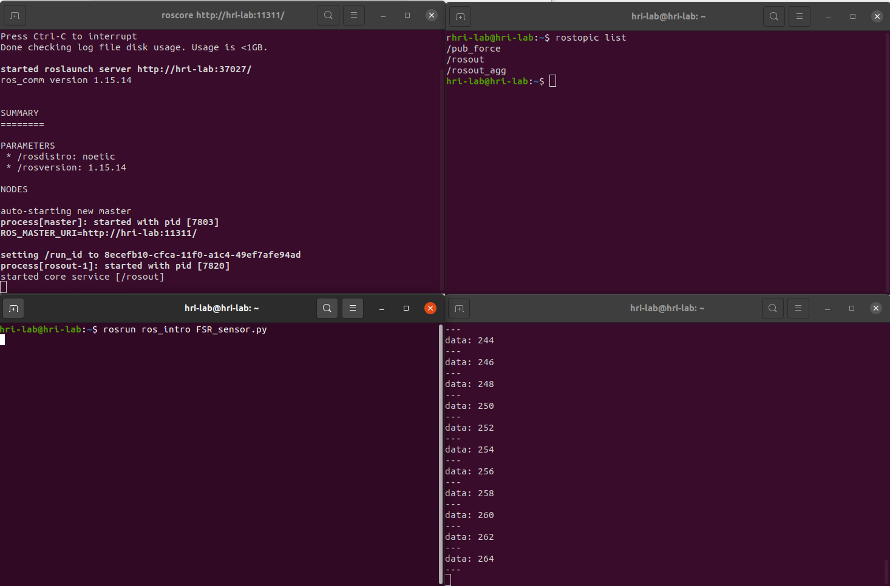

Exercise 3
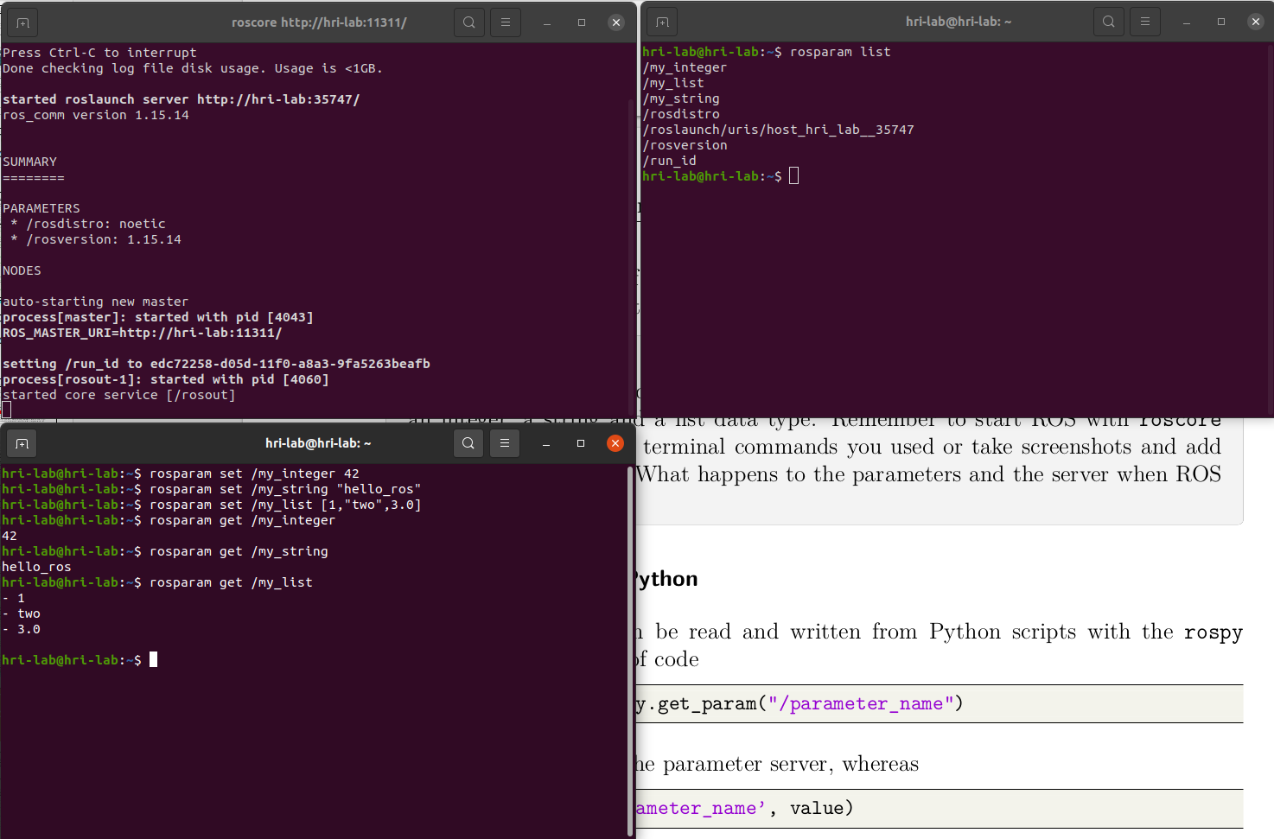

Exercise 4

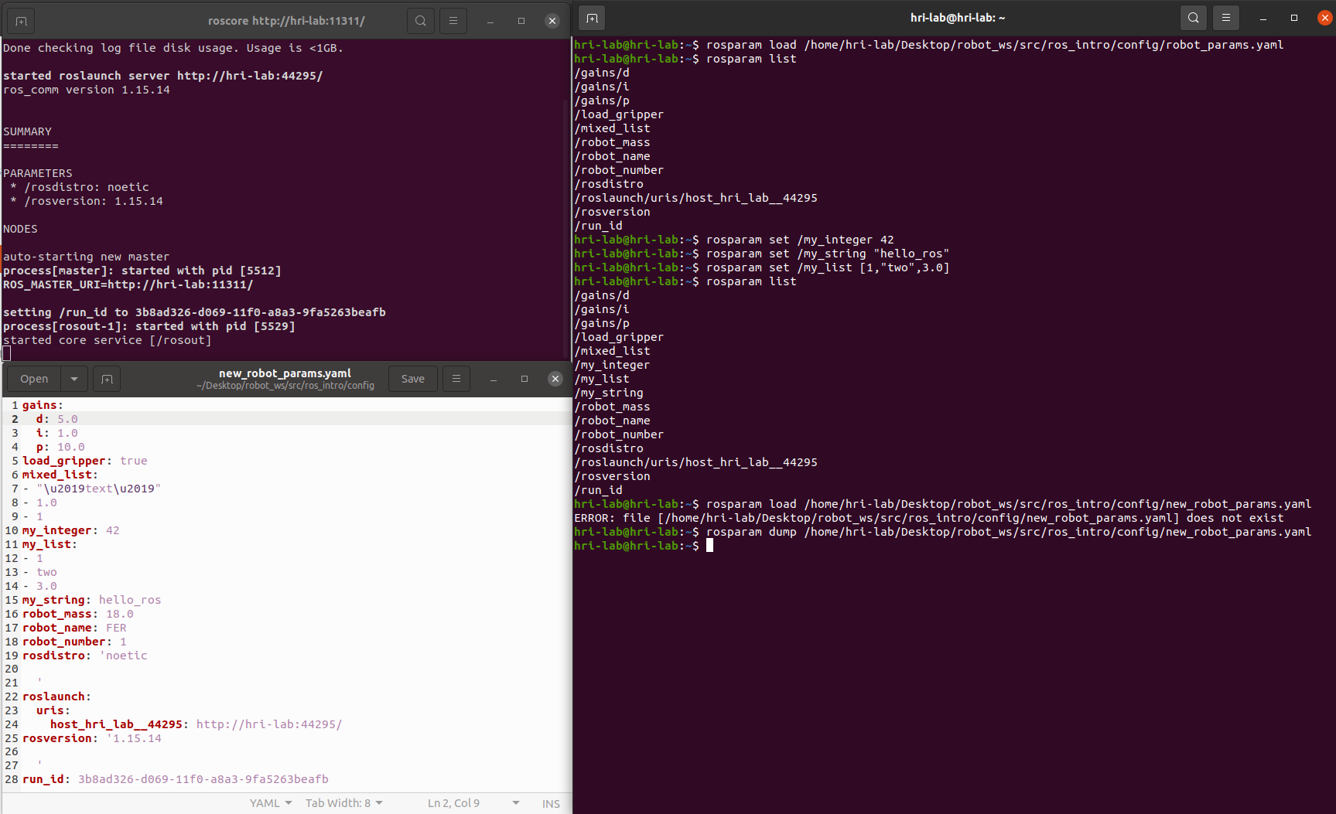
Exercise 5
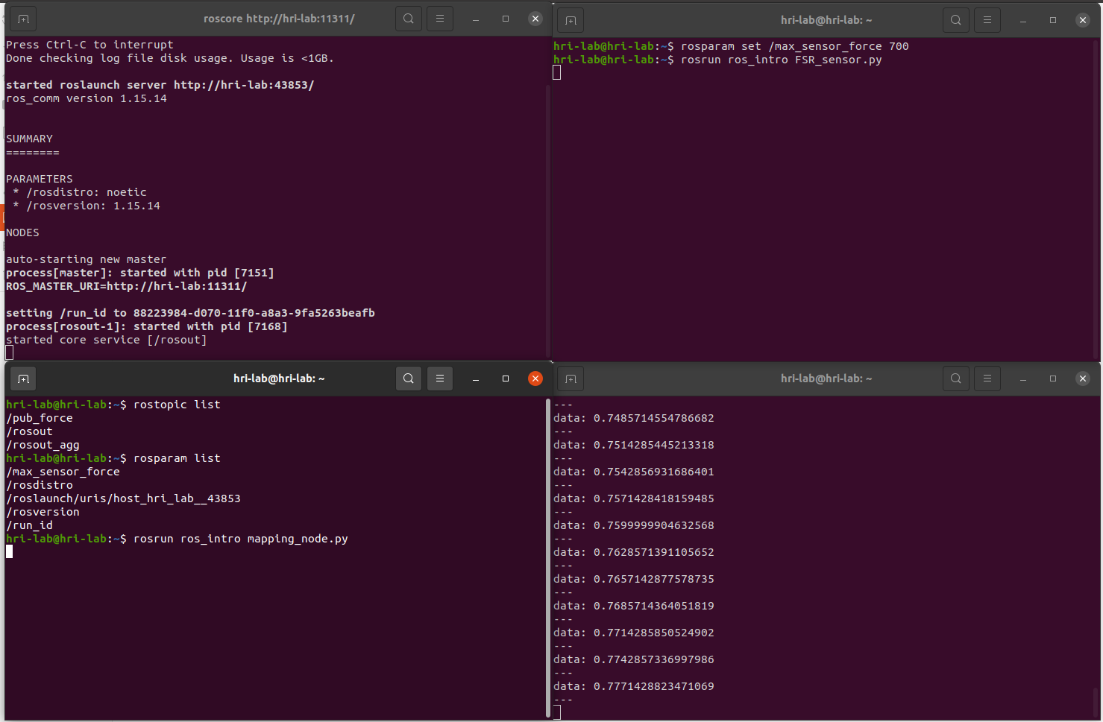

Exercise 6

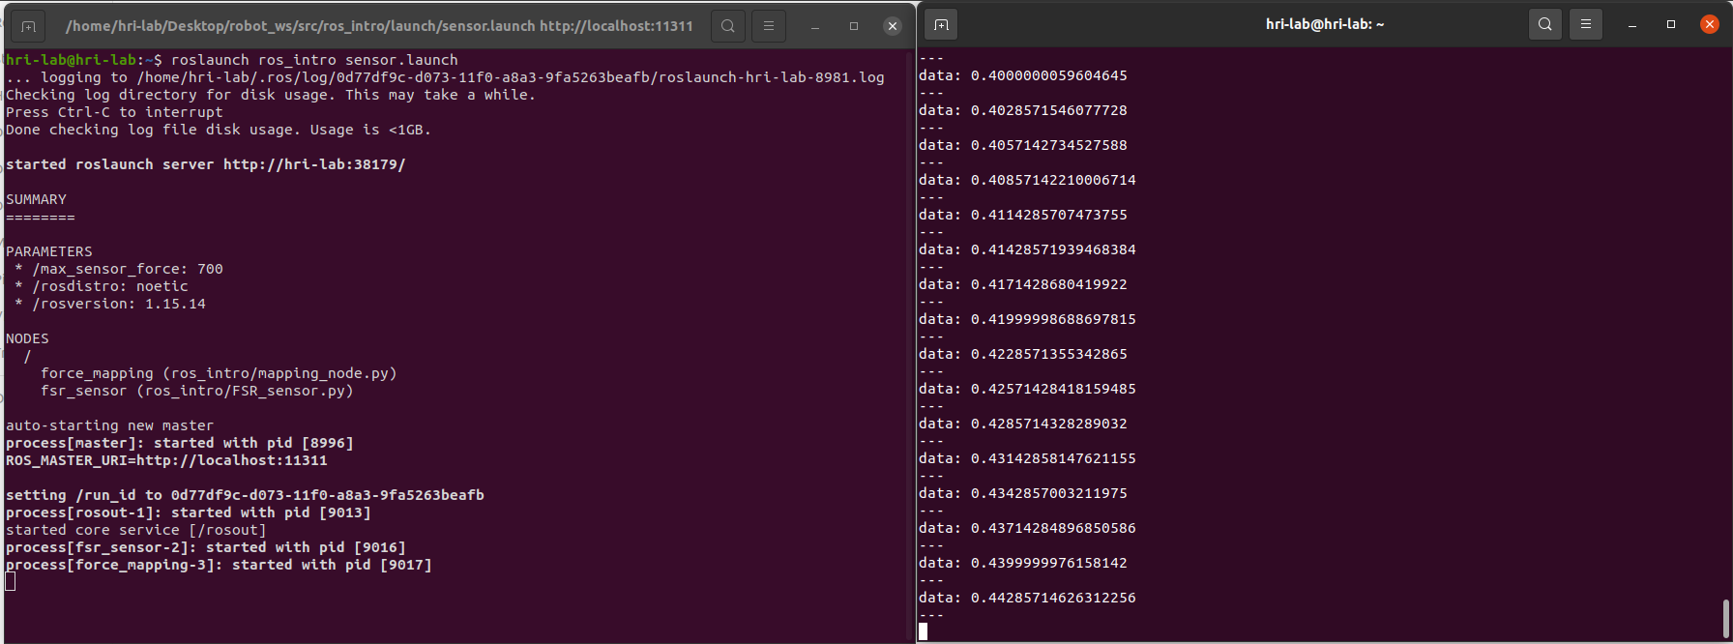

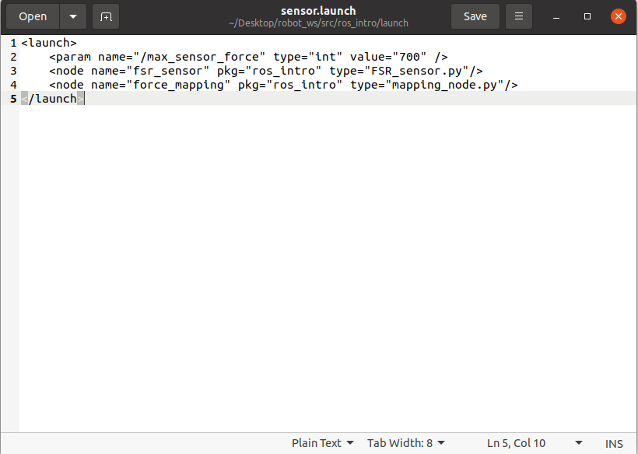

Exercise 7

